**The gross structure and the functions of the human nervous system**

**Organization and main parts of the human nervous system**

Human nervous system consists of central and peripheral nervous systems. In vertebrates, the brain and the spinal cord form the central nervous system. Nerves and ganglia forms the main components of the peripheral nervous system.

**Central nervous system (CNS)**

Central nervous system consists of the brain and the spinal cord. In vertebrates, the CNS develops from the hollow dorsal nerve cord during embryonic development. Anterior part of the central nervous system enlarges and forms the brain which has three major regions: forebrain, mid brain and hindbrain. The central canal in the brain forms four irregular shaped cavities called ventricles. The brain contains four ventricles: three ventricles are present in the fore brain and one ventricle is in the hind brain. This central canal continues in the spinal cord. The ventricles and central canal contains cerebrospinal fluid. This fluid helps to maintain uniform pressure within the CNS and act as a shock absorber between the brain and skull. It also helps to circulates nutrients and hormones as well as to remove waste products.

The brain and the spinal cord have several adaptations to be protected from physical injuries. The brain is enclosed by a skull. The spinal cord is surrounded by vertebrae which forms the vertebral column. Further protection to the CNS is given by three layers of tissues called the meninges. The outermost layer is called the dura mater, the innermost layer as pia mater and in between these two layers is the arachnoid mater.

**Main parts of the human Brain**

The forebrain, mid brain and hindbrain of the human embryo develops into the adult brain. The forebrain gives rise to the cerebrum, thalamus, hypothalamus and pineal body. The mid brain gives rise to part of the brain stem. The hind brain gives rise to cerebellum, pons Varolii and medulla oblongata. The brain stem consists of the mid brain, pons Varolii and medulla oblongata.

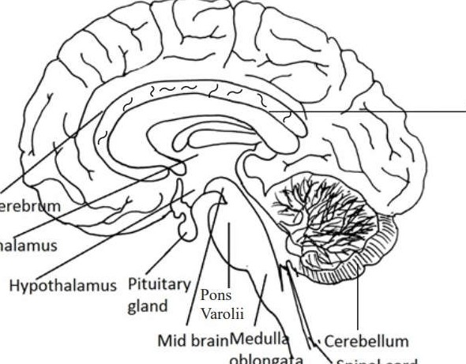

Cerebr

Tha

oblonga

a

Figure 5.3 : The longitudinal view of the human brain

**Cerebrum**

Cerebrum is the largest part of the human brain. It is divided by a deep cleft into right and left cerebral hemispheres. The superficial part of the cerebrum is composed of nerve cell bodies (or grey matter) forming the cerebral cortex and deeper layers consist of nerve fibers (or white matter). The two cerebral hemispheres are connected by corpus callosum which is a mass of white matter. The cerebral cortex shows many infoldings to increase the surface area of the cerebrum. The cortex of each cerebral hemisphere is divided into four lobes: frontal lobe, temporal lobe, parietal lobe and occipital lobe.

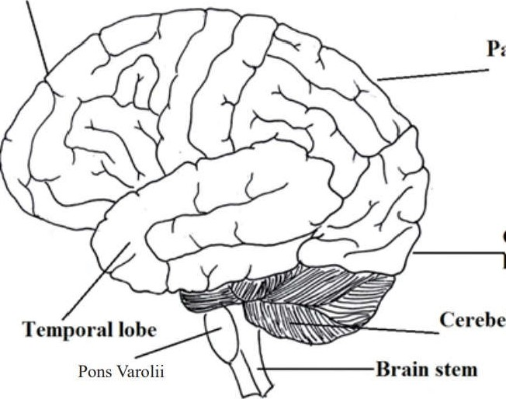

Figure 5.4 : The human cerebral cortex

Three main functional areas of the cerebral cortex have been identified. They are;

* Sensory areas which receive and process sensory information including the perception of pain, temperature, touch, sight, hearing, taste and smell
* Association areas which are responsible for recognition and interpretation of sensory information and integration and processing of complex mental functions such as memory, intelligence, reasoning, judgment and emotions
* Motor areas which are responsible for directing skeletal (voluntary) muscle movement through the initiation and control of voluntary muscle contraction

**Thalamus**

Thalamus is situated within the cerebral hemispheres just below the corpus callosum. It consists of two masses comprising grey and white matter.

**Functions:**

Thalamus acts as the main input centre of sensory information from special sense organs and sensory receptors in the skin and internal organs. This sensory information is sorted and directed to specific location of the cerebral cortex for further processing and perception. The thalamus relays and redistributes nerve impulses from most parts of the brain to cerebral cortex.

**Hypothalamus**

Hypothalamus is situated below and in front of the thalamus, immediately above the pituitary gland. It is linked to the posterior lobe of the pituitary gland by nerve fibers and to the anterior lobe by a complex system of blood vessels.

**Functions:**

* Regulates body temperature
* Regulates thirst and water balance
* Regulates appetite
* Regulate sleep and wake cycles
* Control of autonomic nervous system
* Initiates fight-or-flight response
* Source for posterior pituitary hormones and releasing hormones that act on anterior pituitary.
* Plays a role in sexual behaviours

**Mid brain**

Mid brain is the upper part of the brain stem. It is situated between the cerebrum (above) and the Pons Varolii (below) surrounding the cerebrospinal fluid filled connection of the third and fourth z ventricles. Mid brain contains aggregates of nerve cell bodies and nerve tracts which connect the cerebrum with lower brain and spinal cord.

**Functions:**

* Acts as relay stations for ascending and descending nerve fibers
* Receives and integrates sensory information (auditory and visual) and sends it to particular regions of the forebrain,.
* Coordinates auditory and visual reflexes

**Pons Varolii**

Pons Varolii,(a part of the brain stem) is located in front of the cerebellum, below the mid brain and above the medulla oblongata.lt contains nerve fibers that form a bridge between the two hemispheres of the cerebellum.lt also contain nerve fibers passing between higher levels of brain and spinal cord. Groups of nerve cell bodies in the Pons Varolii form centers that regulate respiration. Some nerve cell bodies in the pons act as relay stations.

**Functions:**

* Transfers information between PNS and the mid brain and forebrain
* Coordinates large scale body movements such as climbing and running
* Together with the medulla oblongata helps regulate respiration.

**Medulla oblongata**

Medulla oblongata is the lowest part of the brain stem which extends from the Pons Varolii above and is continuous with the spinal cord below. It consists of cardiovascular centre, respiratory center and reflex centers.

**Functions:**

* Transfers information between PNS and the mid brain and the fore brain
* Coordinates large scale body movements such as running, climbing
* Controls several autonomic, homeostatic functions including breathing, heart and blood vessel activities (contains respiratory centre, cardiovascular centre)
* Controls involuntary reflexes such as vomiting, swallowing, coughing, sneezing through reflex centres

**Cerebellum**

Cerebellum is located behind the pons Varolii and below the posterior portion of the cerebrum. It is also made up of two hemispheres.

Functions

* Coordinates voluntary muscular movements
* Maintains posture and balance
* Helps in learning and remembering motor skills

Figure 5.5 : T.S of the human brain

**Spinal cord**

The spinal cord is an elongated cylindrical structure suspended in the vertebral canal. It is continuous with the medulla oblongata. Centre of the spinal cord contains the central canal which is surrounded by grey matter. Outer region of the spinal cord is made up of white matter.

**Functions:**

* Links the central nervous systems to sensory and motor neurons and facilitates nerve impulse propagation towards the brain and away the brain
* Coordinates and produces reflexes

Figure 5.6: TS of the spinal cord

Peripheral nervous system (PNS)

Peripheral nervous system is made up of cranial nerves, spinal nerves and autonomic nervous system (with ganglia). It transmits impulses to and from CNS regulating both an animal's movement and its internal environment.

Sensory information from sensory receptors reaches the CNS along PNS neurons referred to as afferent neurons (sensory neurons). Within the CNS this information is processed and instructions are transmitted to effector tissues/organs Onuscles, glands and endocrine cells) along PNS neurons referred to as efferent neurons (motor neurons).

PNS consists of two efferent components;

* The motor system- It consists of neurons that carry nerve impulses to skeletal muscles. So it controls voluntary activities.
* Autonomic nervous system- It generally controls the involuntary activities of the body. Autonomic nervous system consists of neurons which carry impulses to control activities of smooth muscles, cardiac muscles and glands.

**Autonomic nervous system consists mainly of two divisions:**

* Sympathetic division
* Parasympathetic division

**Sympathetic and parasympathetic nervous system**

The majority of the body organs are supplied by both sympathetic and parasympathetic nerves which have antagonistic (opposite) functions. Sympathetic stimulations prepare the body to o3 deal with exciting/ stressful situations and energy generating situations (fight- or -flight). Parasympathetic division causes opposite responses that promote calming or a return to selfmaintenance functions (rest and stimulate digestion and food absorption).

The two divisions differ in overall functions, organization and the signal released. Parasympathetic nerves exit the CNS at the base of the brain or the spinal cord as cranial nerves or spinal nerves respectively. On the other hand sympathetic nerves exit only from the spinal cord. Different neurotransmitters enable the two systems to bring about two opposite effects in different organs z such as lung, heart, intestine and bladder. For example, when the neurotransmitter secreted by the parasympathetic division is acetylcholine, the sympathetic division secretes norepinephrine.

**How nerve impulses are generated and transmitted**

In all cells including neurons, ions are distributed unequally between the cell interior and exterior (extra cellular fluid). Generally the inside of the cell is negatively charged whereas the exterior is positively charged. These opposite charges are attracted across the plasma membrane and as a result it creates a voltage difference across the membrane that is referred to as membrane potential.

**Resting potential**

When a neuron is at rest (when not sending a signal/non conducting), the membrane potential (voltage difference across the membrane) is called the resting potential. In a non-conducting neuron the resting potential is typically between -60 mV and -80 mVl

The resting membrane potential is maintained by;

* Distribution of ion concentrations inside and outside of the neuron. In a non conducting neuron the concentration of K4 is higher inside the cell while concentration ofNa+ is higher outside. There are large anions (proteins) inside the cell in addition to some Cl- ions . As a result a neuron has a negative charge inside the cell and positive charge outside the cell.
* Selective permeability of the plasma membrane to K4 and Na4 ions. There are leaky potassium channels and sodium channels, which are membrane bound proteins. Potassium channels allows only K4 ions to pass whereas sodium channels allow only Na+ to pass. These channels are leaky and allow K' and Na+ to diffuse according to their concentration gradient. However there are more leaky potassium channels open than sodium channels These Potasium channels allow net outflow of Potasium due to chemical concentration gradient.However Sodium ions and other ions can not readily cross the membrane. As a result there is a net negative charge inside the cell.
* Sodium-potassium pump- This pump helps to maintain Na4 and gradient across the membrane by transporting three Na4 out of the cell for every two that it transports in. This pump uses ATP to actively transport these ions.

**Action potential**

An action potential occurs due to a change in membrane potential above a certain value (threshold value) due to a stimulus. The action potential has the following phases: depolarization, repolarization and hyperpolarization.

**Depolarization:** A change in the cell's membrane potential such that the inside of the membrane is made less negative relative to the outside. Depolarization results due to Na inflow from the Sodium channels bound to plasma membrane in response to a stimulus.

**Repolarization:** Sodium channels close blocking Nav inflow. However most potassium channels open permitting K+ outflow. This makes the inside of the cell negative. z

**Hyperpolarization:** Sodium channels are closed but potassium channels are opened. As a result the inside of the membrane is more negative.

**Refractory period**

Refractory period is the short time immediately after an action potential in which the neuron cannot respond to another stimulus, owing to the inactivation of sodium channels. This prevents the reverse conduction of an impulse in an axon.

**Conduction of action potential (nerve impulse)**

* A series of action potentials that move along an axon is defined as a nerve impulse.
* An action potential is generated due to Na+ inflow (depolarization) at one location in the axon.
* This axon potential spreads to the neighboring location while the initial location repolarizes.
* This depolarization-repolarization process is repeated through the axon.

**The speed of conduction depends on:**

* Diameter of the axon- The conduction speed increases with the increase in axon diameter.
* Presence of myelinated axon (in myelinated neuron, axon potential jumps from one node of Ranvier to the next)

**Synapses**

A synapse is the junction where a neuron (presynaptic cell) communicates with another cell (postsynaptic cell) across a narrow gap (synaptic cleft). Postsynaptic cell may be another neuron, muscle cell or secretory cell. This junction where one neuron communicates with the next cell using a chemical (neurotransmitter) is called a chemical synapse. Some neurons can also communicate through direct electrical connections (electrical synapse).

Figure 5.10: A synapse which communicates through a neurotransmitter

**Mechanism of transmission of nerve impulses through chemical synapses**

* An action potential at an axon terminal depolarizes the plasma membrane of presynaptic cell.
* Depolarization at the presynaptic terminal causes Ca2+ to diffuse into the terminals. The rise in Ca2+ causes binding of synaptic vesicles containing neurotransmitters to the presynaptic membrane.
* This results in the release of the neurotransmitters into the synaptic cleft.
* Neurotransmitters diffuse across the synaptic cleft.
* Neurotransmitters bind and activates specific receptors in the postsynaptic cell membrane.
* If acetylcholine is taken for example of a neurotransmitter, the binding of neurotransmitters to the post synaptic membrane allows Na+ and K+ to diffuse across the post synaptic membrane.
* Depolarization takes place in the post synaptic membrane and it reaches the action potential
* After passing the nerve impulse to the postsynaptic cell, the signal at the presynaptic terminals is terminated either by:
* Enzymatic hydrolysis of neurotransmitters
* Recapture of neurotransmitter into the presynaptic terminals.

**Neurotransmitters**

Neurotransmitters are the molecules that are released from the synaptic terminals of presynaptic neuron and diffuse across the synaptic cleft, bind to the receptors at the postsynaptic membrane, triggering a response.

Common neurotransmitters are;

* Acetylcholine
* Some amino acids
* Biogenic amines
* Neuropeptides
* Some gases

Reflex arc

Reflex arcs are the functional unit of the vertebrate nervous system. Typically a reflex arc consists of three neurons. They are

1. Afferent/ Sensory neuron
2. Interneuron
3. Efferent/ Motor neuron

A sensory neuron transmits impulses from a sensory receptor to the central nervous system where it synapses with an associated neuron called interneuron. This impulse is transmitted to a motor neuron. The motor neuron conveys the signal to effector tissues/organs.

**Common disorders of the nervous system**

Common disorders of the nervous system are Schizophrenia, Depression, Alzheimer's disease and Parkinson 's disease.

* **Schizophrenia**: This is a severe mental disturbance characterized by psychotic episodes in which patients have a distorted perception of reality. They experience voices that only they can hear. They think that others are plotting to harm them. Evidence suggests that this disorder affects neural pathways that use dopamine as a neurotransmitter.
* **Depression:** Depression is likely to be due to a complex combination of factors that include: Changes in neurotransmitter levels in the brain, genetics, psychological, social, environmental factors .People who are suffering from this disorder show depressed mood, abnormalities in sleep, appetite and energy level. In some conditions once enjoyable z activities are no longer pleasurable or interesting. Some conditions involve extreme mood swings. Effective therapies are available to increase activity of some neurotransmitters in the brain
* **Alzheimer's disease:** This is a severe mental deterioration (dementia) characterized by confusion and memory loss. Patients are gradually becoming less able to dress, bathe and feed themselves. They lose their ability to recognize people including their immediate family members. Cause of the disease is due to progressive and irreversible degeneration of neurons in the brain especially in cerebral cortex with deteriorating mental functioning. The disease affects elderly people. Genetic factors may be involved. So far, there is no cure for this disease.
* **Parkinson disease:** This is a progressive motor disorder that leads to lack of control and coordination of muscle movements. The patients show slowness of movements, difficulty in intiating movements, poor balance; fixed muscle tone causing lack of facial expression; speech problems and muscle tremor of extremities: e.g. shaking a hand, fingers in one hand, shaking head. This disease is associated with gradual degeneration of dopamine neurotransmitter releasing neurons in the brain (mid brain, basal ganglia). The disease is common in the elderly people. Genetic factors may be involved. Disease can be treated but not cured.

## Comparison of Sympathetic and Parasympathetic Nervous Systems

The autonomic nervous system (ANS) consists of two divisions, the sympathetic and parasympathetic systems, which work antagonistically to regulate involuntary functions in the body. The table below provides a detailed comparison of these two systems.

|  |  |  |
| --- | --- | --- |
| Aspect | Sympathetic Nervous System | Parasympathetic Nervous System |
| Primary Role | Prepares the body for 'fight or flight' responses | Promotes 'rest and digest' activities |
| Heart Rate | Increases | Decreases |
| Pupil Response | Dilates pupils | Constricts pupils |
| Digestive Activity | Decreases | Increases |
| Bronchi in Lungs | Dilates | Constricts |
| Neurotransmitters | Norepinephrine | Acetylcholine |
| Effect on Blood Vessels | Constricts in skin and digestive organs, dilates in skeletal muscles | No significant effect |
| Energy Utilization | Promotes energy expenditure | Conserves energy |